**TABLEAU DATAVIZ CHALLENGE**

**TRAVEL & TOURISM.**

**1 INTRODUCTION**

**1.1 Overview**

This project was made with an idea on how one can analyse multiple aspects of a dataset that is obtained by the tourists that arrive to India. This project adds multiple aspects like Purpose of visit of the tourists,Number of Arrivals,Age distribution,Gender distribution etc. and shows them individually as different parts of story as well as combined by using dashboard and adding that dashboard to the story.

**1.2 Purpose**

Using this project one can analyse the various aspects in a single story/dashboard.The various graphs help in a better understanding of the data which can further be used for developement of tourism in India.

**2 Literature Survey**

**2.1 Existing Problem**

Most of the data remains in textual format which is of no use as it is difficult to understand and even the yearly reports provided by tourism sector are mostly in tabular form which can be found in tourism.gov.in.

**2.2 Proposed Solution** With data visulaization tools we can visualize this data and get a better understanding of each and every aspect of the dataset and therefore comeup with any solution faster.

**3 Theoretical Analysis**

**3.1 Hardware / Software designing**

For this project the only tool used was Tableau desktop which can be installed on any desktop/Laptop. One can also use Tableau online in any browser but the preffered tool would be tableau desktop.

**4 Experimental Investigations**

While working on the solution it was observed that how can a graph can change the whole meaning of the data and it is essential to choose the right graph for the right data.

**5 Result**

First I have created a geographically classified visualization.

The colour density represents the number of tourists from that country, the more dense the colour, the more people, and vice versa.

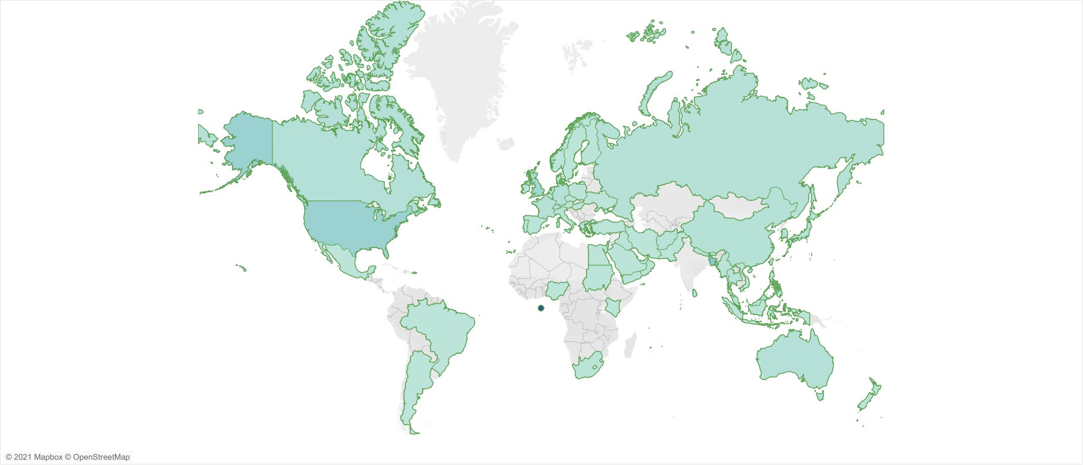

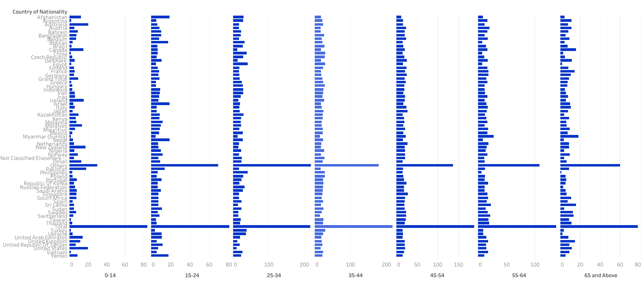

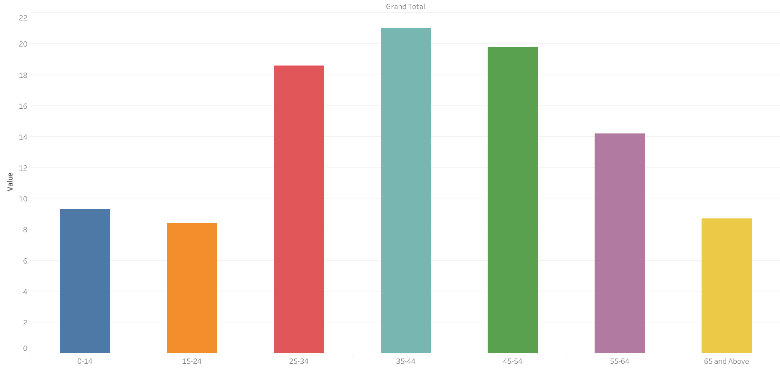

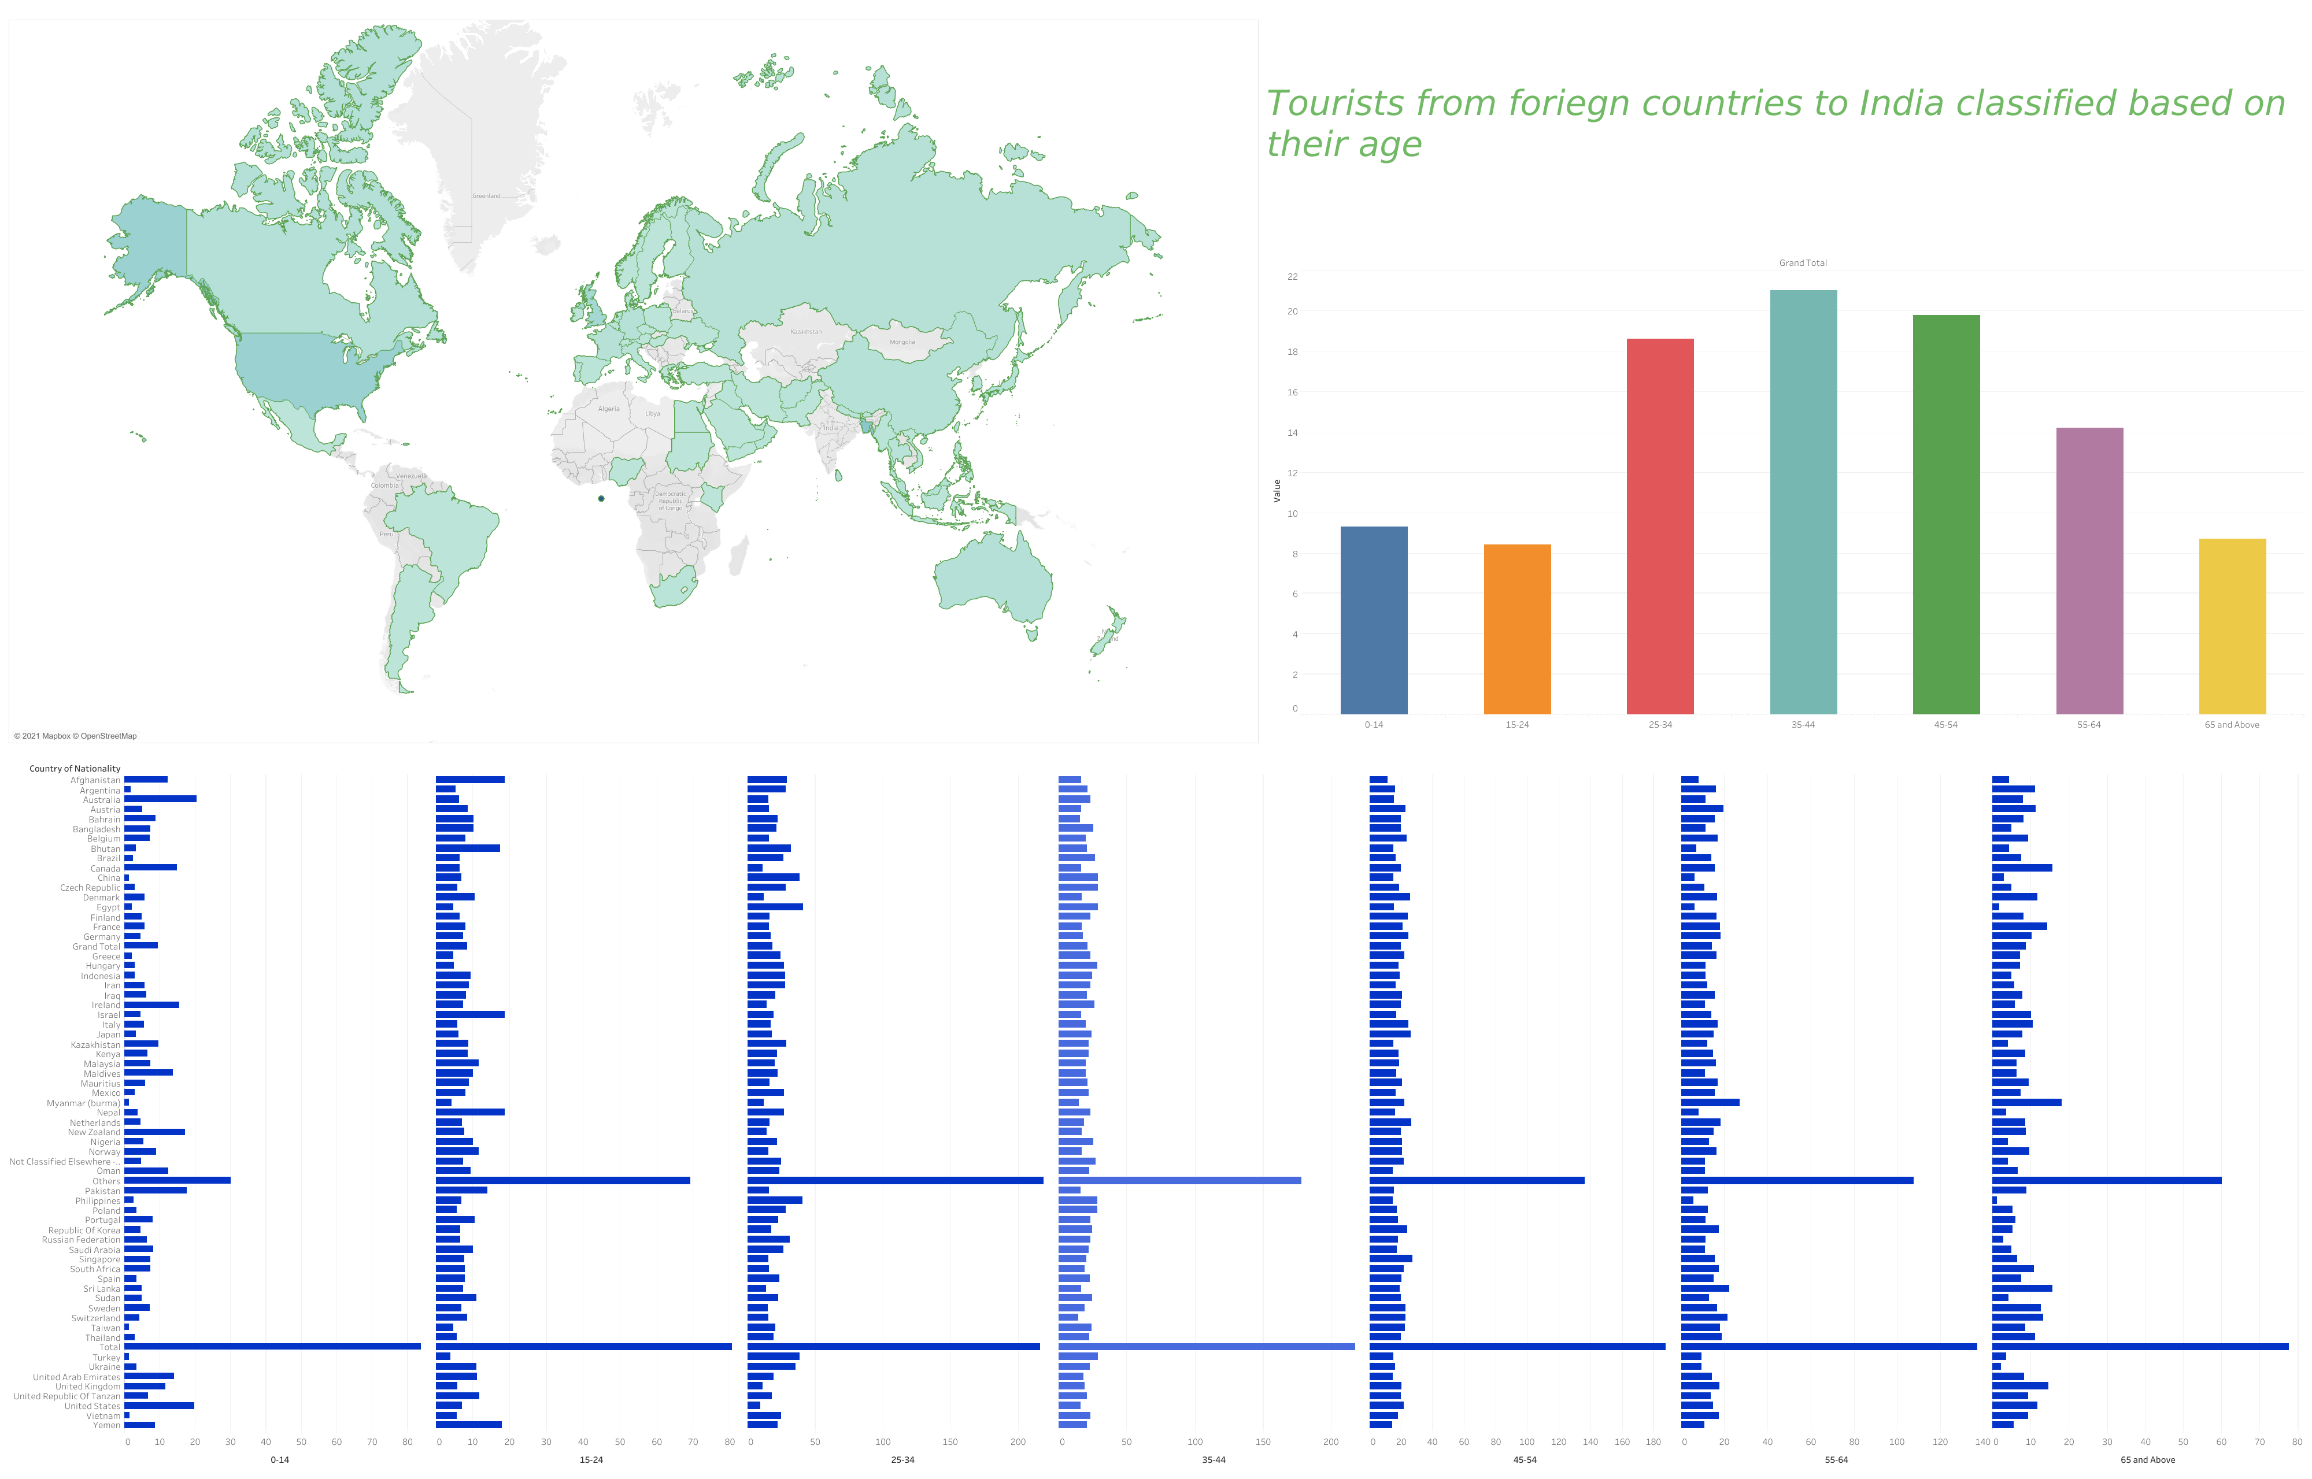

**6Advantages and Disadvantages**

The main advatage is that data is in graphical format which helps in better understanding and analysis and the major drawback is that the data is only for one year and if it were of 2-3 years ,regression algorithms could have been applied to predict the tourists for future years and make suitable arrangments.

**7Applications**

The following dataviz can be used by in the tourism sector for understanding the data for future predictions and many other applications

.**8Conclusion**

To summarize each and every graph in this project shows a visualization of each aspect and helps us understand the data better which would have been challenging in case of raw data.The raw data alone is of no use lest it is processed and visualized to predict or for other applications.

**9 Future Enhancements**

In future we can add more years of data for visualization and compare data yearwise.We can also apply regression algorithms after adding more data and make suitable arrangements for the tourists of future.

**10 Bibliography**

The following resources were used for the completion of this project

*https://public.tableau.com/en-us/s/